Namespace is collection of related Classes, Enums, Delegates, Namespace, Structs etc.

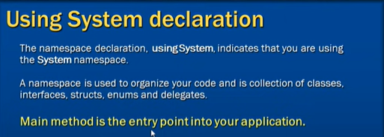

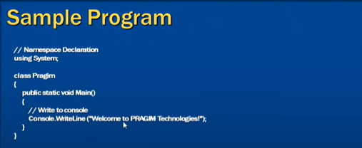

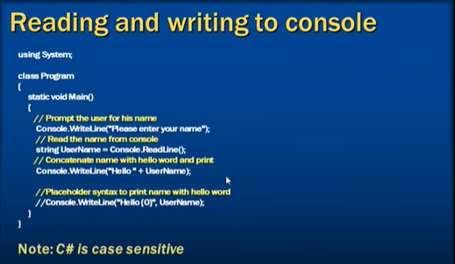





| **C# type/keyword** | **Range** | **Size** | **.NET type** |
| --- | --- | --- | --- |
| sbyte | -128 to 127 | Signed 8-bit integer | [System.SByte](https://docs.microsoft.com/en-us/dotnet/api/system.sbyte) |
| byte | 0 to 255 | Unsigned 8-bit integer | [System.Byte](https://docs.microsoft.com/en-us/dotnet/api/system.byte) |
| short | -32,768 to 32,767 | Signed 16-bit integer | [System.Int16](https://docs.microsoft.com/en-us/dotnet/api/system.int16) |
| ushort | 0 to 65,535 | Unsigned 16-bit integer | [System.UInt16](https://docs.microsoft.com/en-us/dotnet/api/system.uint16) |
| int | -2,147,483,648 to 2,147,483,647 | Signed 32-bit integer | [System.Int32](https://docs.microsoft.com/en-us/dotnet/api/system.int32) |
| uint | 0 to 4,294,967,295 | Unsigned 32-bit integer | [System.UInt32](https://docs.microsoft.com/en-us/dotnet/api/system.uint32) |
| long | -9,223,372,036,854,775,808 to 9,223,372,036,854,775,807 | Signed 64-bit integer | [System.Int64](https://docs.microsoft.com/en-us/dotnet/api/system.int64) |
| ulong | 0 to 18,446,744,073,709,551,615 | Unsigned 64-bit integer | [System.UInt64](https://docs.microsoft.com/en-us/dotnet/api/system.uint64) |
| nint | Depends on platform | Signed 32-bit or 64-bit integer | [System.IntPtr](https://docs.microsoft.com/en-us/dotnet/api/system.intptr) |
| nuint | Depends on platform | Unsigned 32-bit or 64-bit integer | [System.UIntPtr](https://docs.microsoft.com/en-us/dotnet/api/system.uintptr) |

| **C# type/keyword** | **Approximate range** | **Precision** | **Size** | **.NET type** |
| --- | --- | --- | --- | --- |
| float | ±1.5 x 10−45 to ±3.4 x 1038 | ~6-9 digits | 4 bytes | [System.Single](https://docs.microsoft.com/en-us/dotnet/api/system.single) |
| double | ±5.0 × 10−324 to ±1.7 × 10308 | ~15-17 digits | 8 bytes | [System.Double](https://docs.microsoft.com/en-us/dotnet/api/system.double) |
| decimal | ±1.0 x 10-28 to ±7.9228 x 1028 | 28-29 digits | 16 bytes | [System.Decimal](https://docs.microsoft.com/en-us/dotnet/api/system.decimal) |

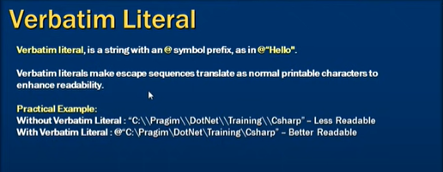

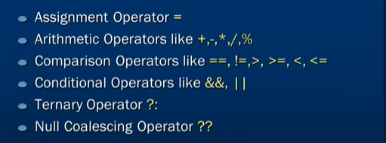

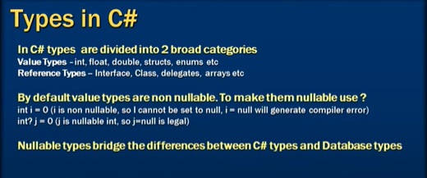



*= value ?? default value (If value is null then default value will get assigned to left side variable)*

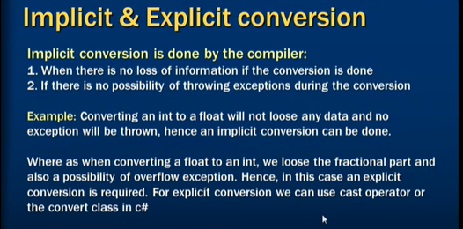

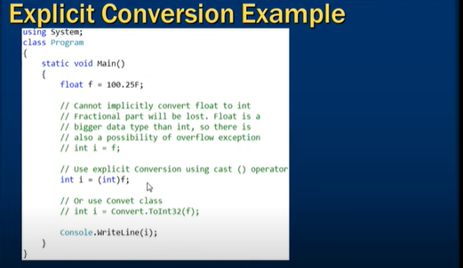

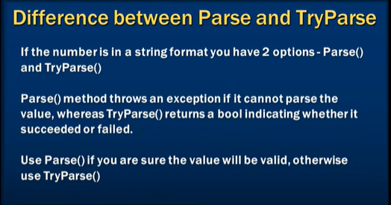

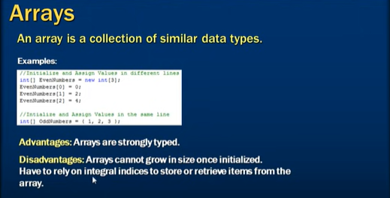

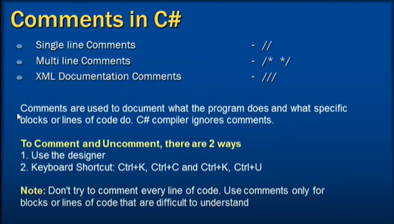

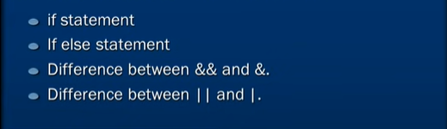

Short Circuit Expressions : && ||

&,| 🡺 executes both the expression while &&,|| skips others based on the condition

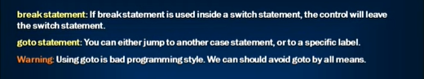

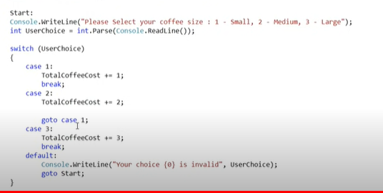



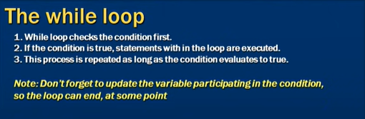

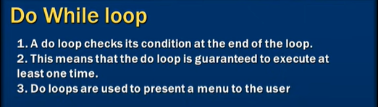

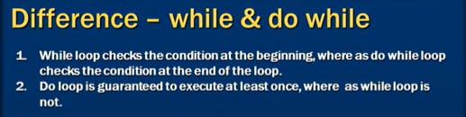





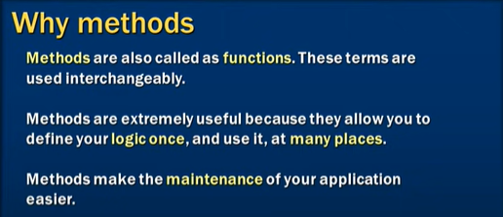

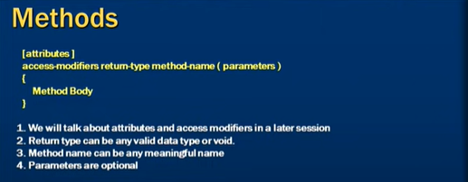

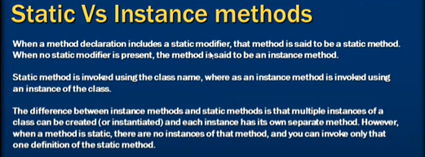

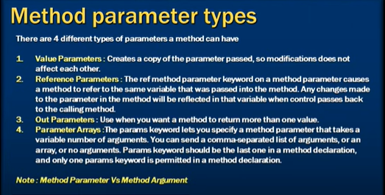

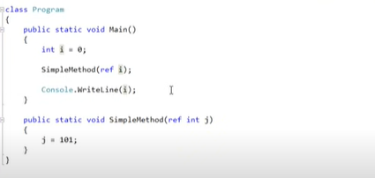

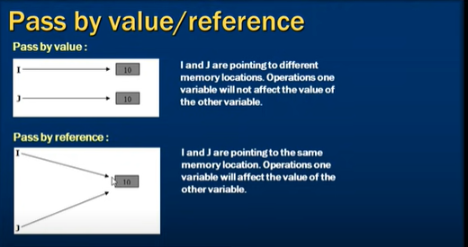

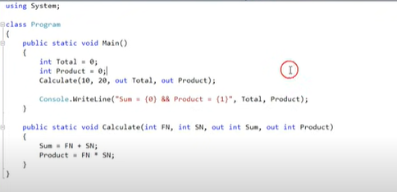

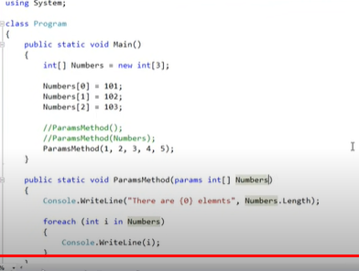



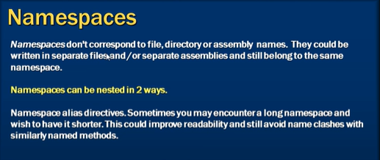

Both are same

|  |  |
| --- | --- |
| namespace ProjectA.TeamA  {  } | namespace ProjectA  {  namespace TeamA  {  }  } |

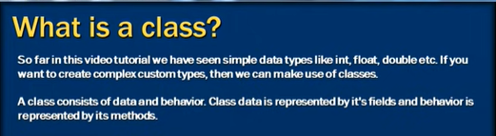



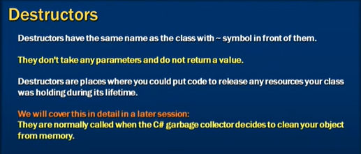

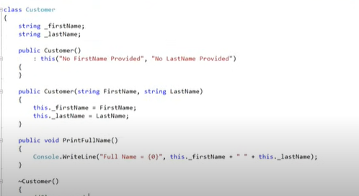

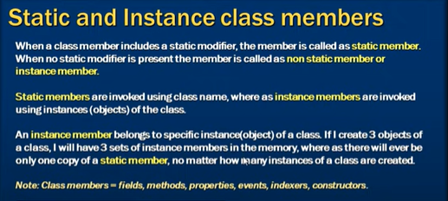

**Static property**: Property which is not going to change with respect to the instances so its better to create it as a static one, another benefit of doing so is that it will avoid creating multiple memory block for same property in each instance in heap

|  |  |
| --- | --- |
|  |  |

To initialize the instance member, we can initialize it in Instance Constructor, similarly, to initialize the static member we can initialize it in static constructor.

Static constructor cannot have any Access Modifier. And called automatically before accessing any of the fields of the Class, Called only once.

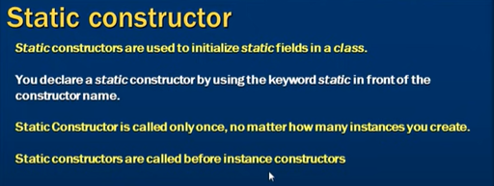

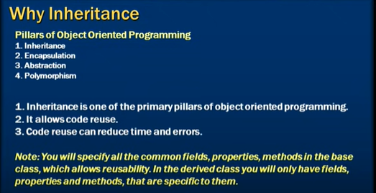

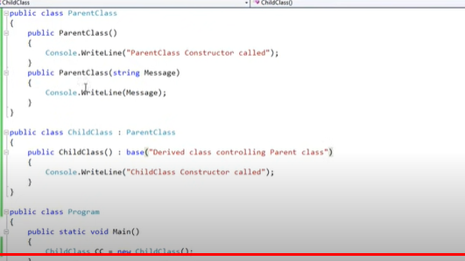

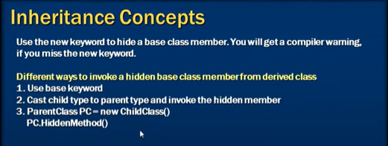

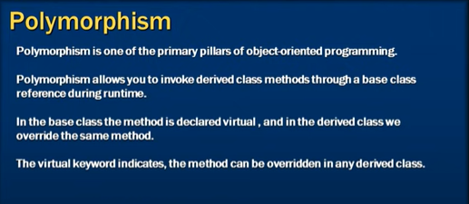

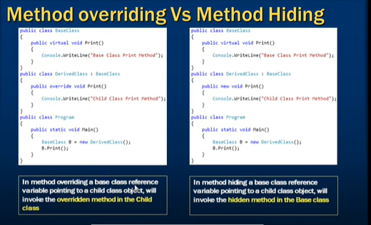

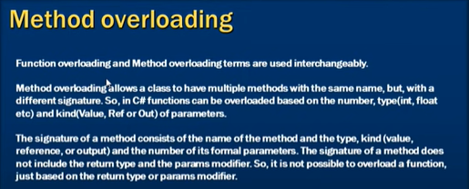

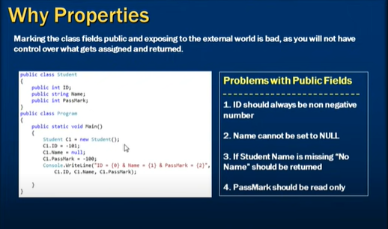





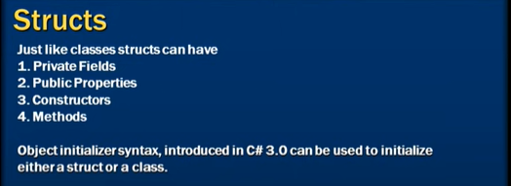

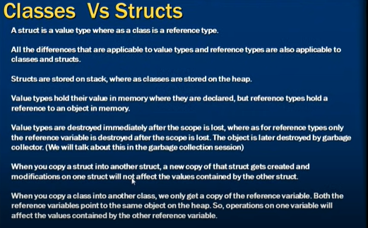



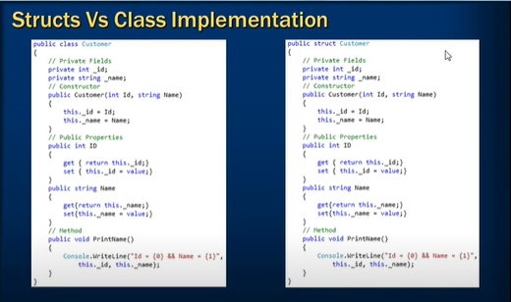

*Structs always have the default constructor

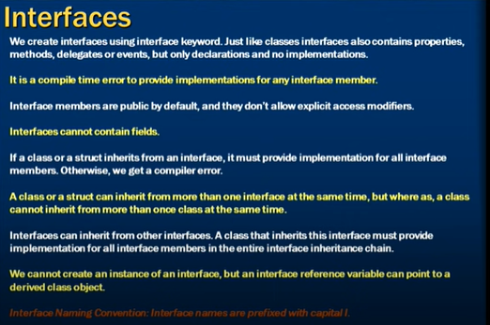

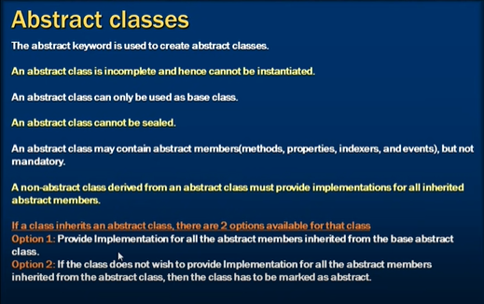

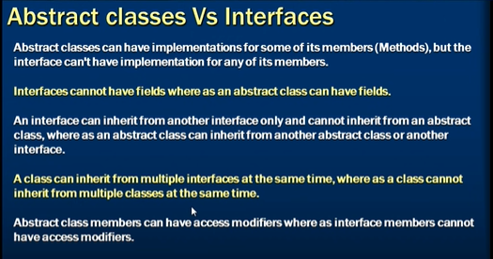

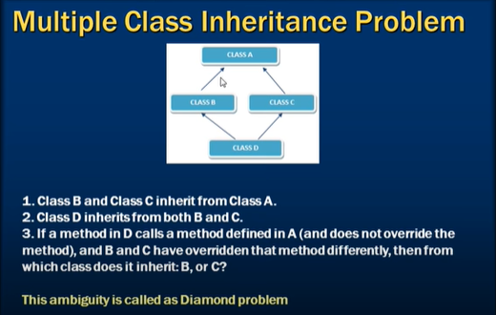

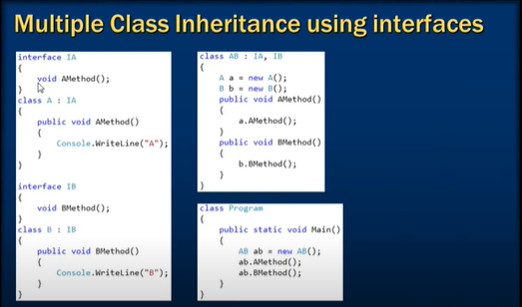

A delegate is a type-safe function point

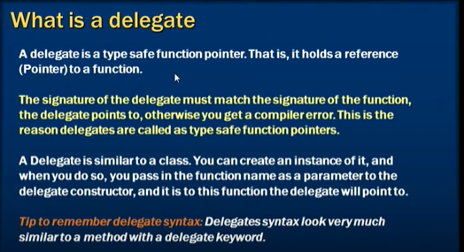

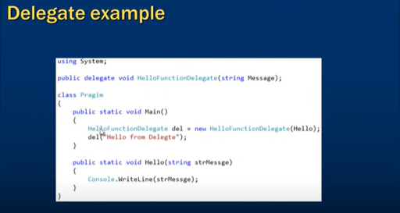

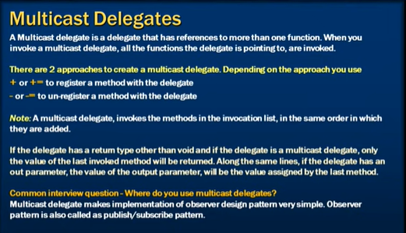

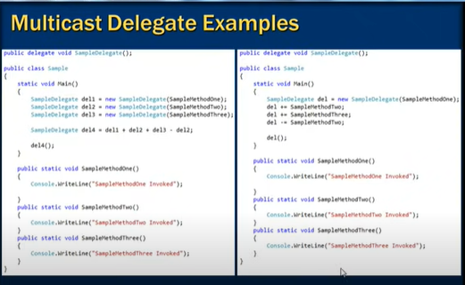

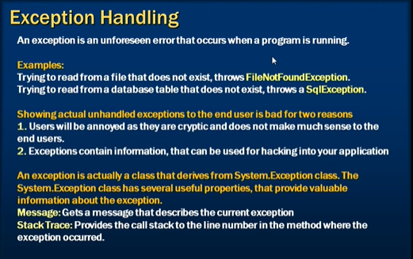

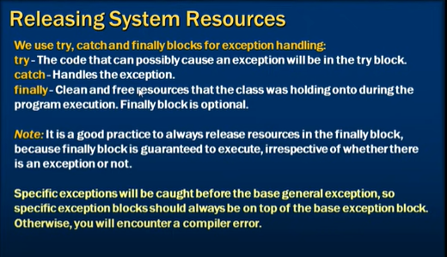

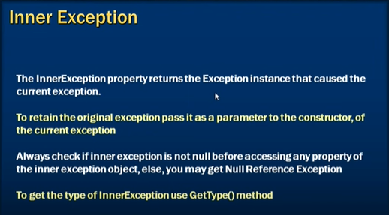

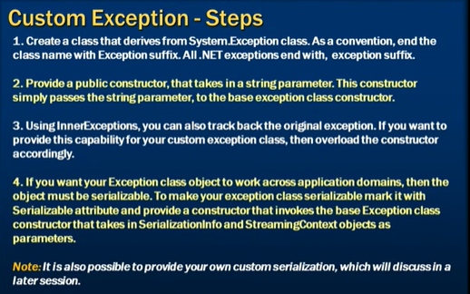

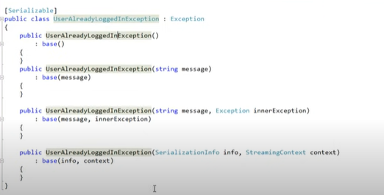

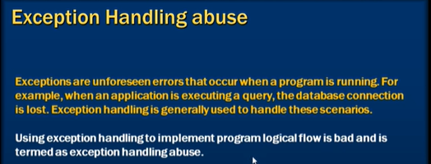

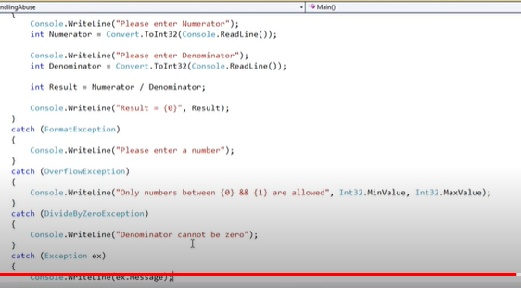

Handling Exception Handling Abuse

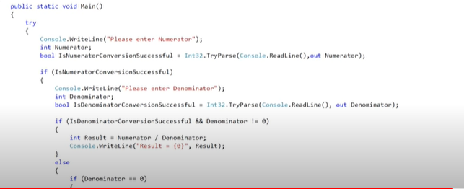

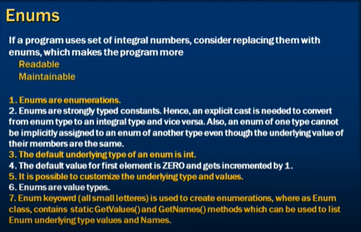

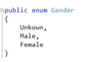

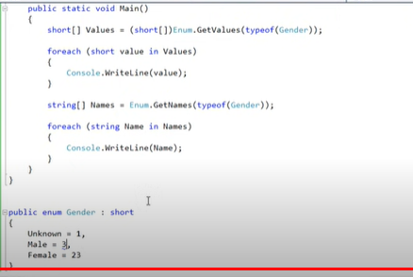

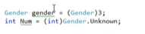

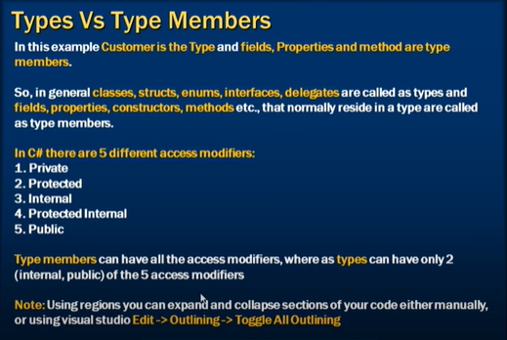

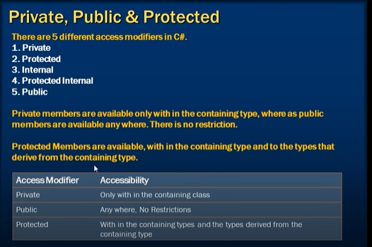

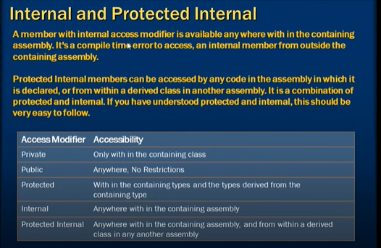

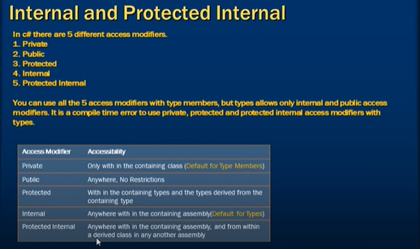

Default Access Modifier for Types🡺 internal

Default Access Modifier for Type Members🡺 private

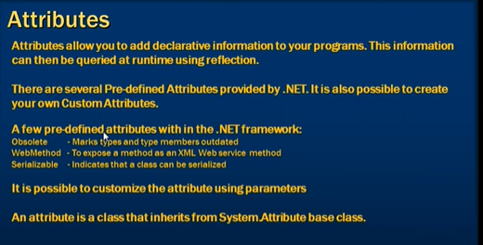

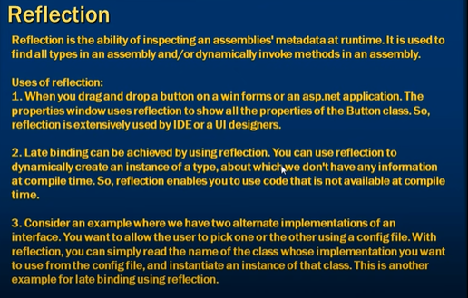

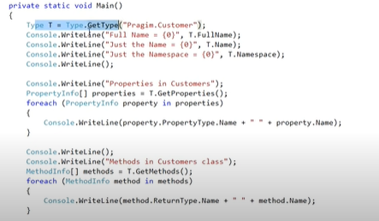

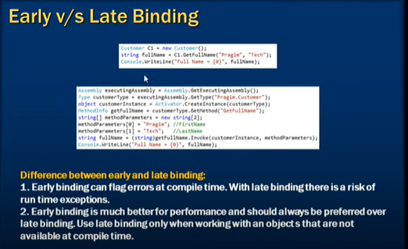

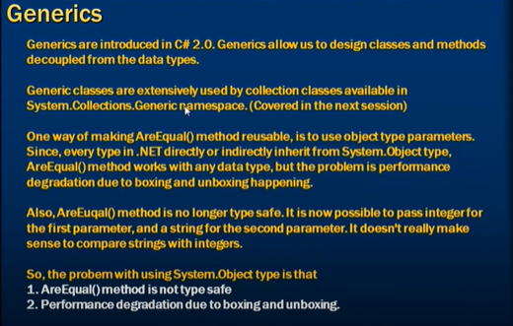

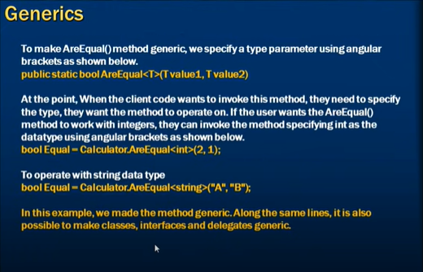

There are four methods get Inherited from the *System.Object* to every types

1. GetType (Cannot be extended)
2. ToString
3. Equals
4. GetHashCode

Always recommended to override GetHashCode too if Equals is being overridden.

ToString: Should be overridden in every type to provide the string representation of the instance, let say if you have a *Customer* class then ToString of that instance might return Last Name, First Name, Id etc. so you could identify *Customer* Instance right away.

Equals:

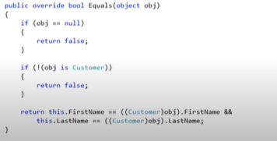

GetHashCode:

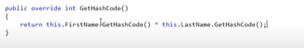

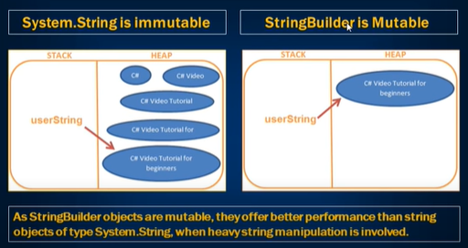

The CLR implements an array to store strings. Arrays are a fixed size data structure, meaning that they cannot be dynamically increased or decreased in size. Once an array is assigned a size, the size cannot be changed. To make an array larger, the data must be copied and cloned into a new array, which is put into a new block of memory by the CLR.

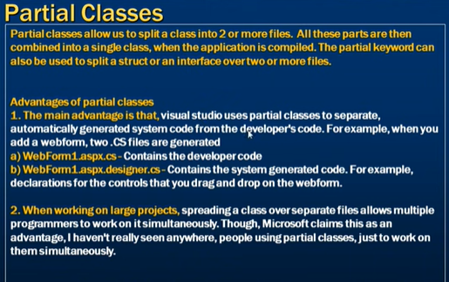

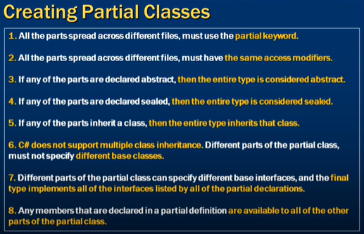

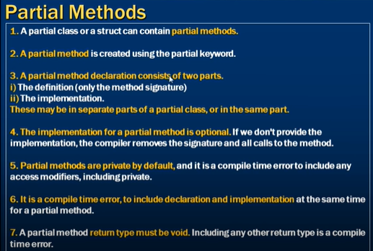

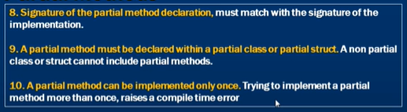

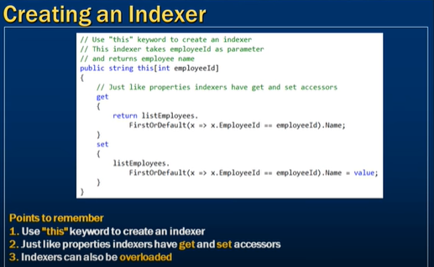

Indexers cannot have return values as void type

Override Indexers

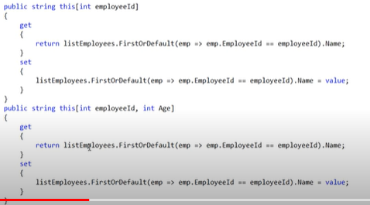

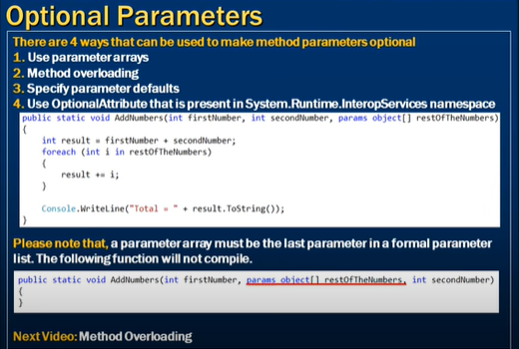

Optional Parameters

1. params int[]
2. default value assignment
3. [optional] attribute

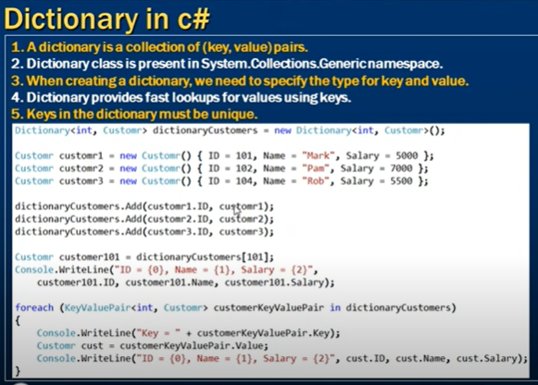

Array to Dictionary



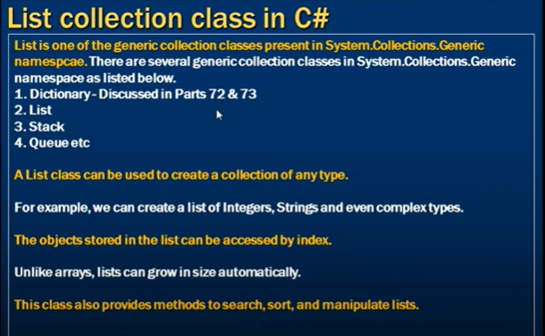

List<>.Insert(index, item)🡺 other items after given index will get pushed one index down

List<>.IndexOf(item)

List<>.IndexOf(item, startIndex )

List<>.IndexOf(item, startIndex, endIndex)

